Test Description: **Smoke** test for rebar App  
Check the basic functionality of the rebar App

|  |  |
| --- | --- |
| **Test Purpose:** Make sure you can do the entire process of logging in and placing an order in the Rebar app  **Test Run Instructions: <Describe any special instructions needed to execute this test>** | |
| **Test Run Information:**  **Tester Name:** **sara hayat**  **Date of Test:** **26/11/2023** | **Prerequisites for this test:** sim |
| **Software Versions:8.5.2**  Application: **rebar,Google Play**  Operating System: **Android 5.1** |
| **Required Configuration: new user** |
| **NOTES and RESULTS:** | |

| **TEST SCRIPT STEPS/RESULTS** | | | | | |
| --- | --- | --- | --- | --- | --- |
| **STEP** | **TEST STEP/INPUT** | **EXPECTED RESULTS** | **ACTUAL RESULTS** | **Requirements Validated** | **PASS/FAIL** |
| Smoke | | | | | |
| 1 | Navigate to Google Play and install the rebar application | The installation process of the application will be carried out | The installation process of the application has been completed |  | pass |
| 2 | Click on open button | The app will open | The app has opened |  | pass |
| 3 | swipe right 4 times | Each scroll shows a different page with an explanation of the rebar app | With each scroll, another page appeared with an explanation of the rebar application |  | pass |
| 4 | Click on Start button | A registration details page will appear | A page of registration details appeared |  | pass |
| 5 | Type “0527702270” in the field “What is your mobile phone?” | The "click here and the code is yours" button will change color to black and will be clickable | The "click here and the code is yours" button changed color to black and could be clicked |  | pass |
| 6 | Type the code sent to your mobile in an SMS message | will move to “בואו נכיר” screen | Moved to the “בואו נכיר” screen |  | pass |
| 7 | Type "שרה" in the First Name field and "חייט" in the Last Name field | will be accepted successfully | Successfully accepted |  | pass |
| 8 | Click on the button "You can move forward" | will move to “let’s celebrate!” page | Moved to the “let’s celebrate!” page |  | pass |
| 9 | Type 08/09/2002 in the field let's celebrate | will be accepted successfully | Received successfully |  | pass |
| 10 | Click on I confirm my joining and I have read the regulations and press the button to proceed | The button "it is possible to advance" will change color and will be clickable | The button "it is possible to move forward" changed color and could be clicked |  | pass |
| 11 | Choose 5 categories: “wellness”, ”mix&creamy”, “im hungry”, “kids”,”rebar slim” | will be selected successfully | will be selected successfully |  | pass |
| 12 | Click on the button “can proceed" | will be accepted successfully and the main screen will open | Successfully accepted and the main screen opens |  | pass |
| 13 | Click on “Select Branch” button | A page will open with a list of branches and a search bar | A page with a list of branches and a search bar opened |  | pass |
| 14 | Type חיפה in the search box | A drop-down list of branches in Haifa will appear | A drop-down list of branches in Haifa appeared |  | pass |
| 15 | Choose “ חיפה-ביג קריות” branch | A page with details about the branch will open | A page with details about the branch opened |  | pass |
| 16 | Click on “Start Order” button | The main page will open | The main page opened |  | pass |
| 17 | Click the menu button | The menu will open with all categories and a search bar | The menu opened with all categories and a search bar |  | pass |
| 18 | Type "חמאת בוטנים" in the search box | A dropdown list will open | A dropdown list has opened |  | pass |
| 19 | Choose ”חמאת בוטנים” from the list | Results for drinks containing peanut butter will be shown | Results were shown for drinks containing peanut butter |  | pass |
| 20 | Press on  “creamy peanut butter” | A page will open with details about “creamy peanut butter” What does it contain, size selection, on what basis?, sweetness level, what to change?, would you like to upgrade? | A page opened with details about “creamy peanut butter” What does it contain, size selection, on what basis?, sweetness level, what to change?, would you like to upgrade? |  | pass |
| 21 | Choose M in the Size Selection field | You can choose | It was possible to choose |  | pass |
| 22 | Click on button “to pay” | The payment page will open and a pop-up message will appear "You might like this" | The payment page opened, a pop-up message appears "You might like this" |  | pass |
| 23 | Press the button “another time” | The pop-up message will close and the payment page with the details of the product you selected will appear | The pop-up message closed and the payment page with the details of the product you selected appeared |  | pass |
| 24 | Click on “Total to Pay 26₪ “ button | The order scheduling page will open | The order scheduling page has opened |  | pass |
| 25 | Choose the button "In about 15 minutes" and click Continue | A page will open on how you would like to pay | A How would you like to pay page has opened |  | pass |
| 26 | Select the "Credit Card" button and click the button “to pay” | A credit information page will open | The credit information page has opened |  | pass |
| 27 | Fill in the credit card information in the appropriate fields and click on “save” button | A message will appear that your order was successfully placed. Go to the branch in about 15 minutes and your order will be ready | A message appeared Your order was successfully placed Go to the branch in about 15 minutes Your order will be ready |  | pass |
| 28 | Open the SMS | Receive an SMS message that the order has been successfully sent to the branch I chose | will receive an SMS message that the order has been successfully sent to the branch I chose |  | pass |
| 29 | Open rebar app and click Logout | It will disconnect successfully and the registration page will open | Log out successfully and the registration page will open |  | pass |

Test Description:   
check the feature **sign up** on “rebar” App

|  |  |
| --- | --- |
| **Test Purpose:**  check the sign up feature the First name, last name, phone number, date of birth, and priority categories  **Test Run Instructions: <Describe any special instructions needed to execute this test>** | |
| **Test Run Information:**  **Tester Name:** **Sara Hayat**  **Date of Test:** **28/11/2023** | **Prerequisites for this test:** sim |
| **Software Versions:8.5.2**  Application: **rebar,Google Play**  Operating System: **Android 5.1**: |
| **Required Configuration: new user** |
| **NOTES and RESULTS:** | |

| **TEST SCRIPT STEPS/RESULTS** | | | | | |
| --- | --- | --- | --- | --- | --- |
| **STEP** | **TEST STEP/INPUT** | **EXPECTED RESULTS** | **ACTUAL RESULTS** | **Requirements Validated** | **PASS/FAIL** |
| **Functionality** | | | | | |
|  | Navigate to sign up page | The signup page will open | The signup page opened |  | pass |
| **Error handling** | | | | | |
|  | Type “05277022” in the field “What is your mobile phone?” | It is not possible to click on the button "Click here and you have the code" | It is not possible to click on the button "Click here and you have the code" |  | pass |
|  | Type “3420000000” in the field “What is your mobile phone?” | An error message "Enter a valid number" will appear. | "Enter a valid number" error message appeared |  | pass |
| **Functionality** | | | | | |
| 4 | Type “0527702270” in the field “What is your mobile phone?” | The "click here and the code is yours" button will change color to black and will be clickable | The "click here and the code is yours" button changed color to black and could be clicked |  | pass |
| 5 | Type the code sent to your mobile in an SMS message | will move to the next screen | Moved to the next screen |  | pass |
| **Error handling** | | | | | |
|  | Type "שרה" in the First Name field and Last Name field leave empty | It is not possible to click on the button “You can move forward” | It is not possible to click on the button “You can move forward” |  | pass |
|  | Type "חייט" in the Last Name field and First Name field leave empty | It is not possible to click on the button “You can move forward” | It is not possible to click on the button “You can move forward” |  | pass |
|  | Type "שרה" in the First Name field and "חייט" in the Last Name field and Delete | An error message "Required field" will appear. | A "required field" error message appeared |  | pass |
| **Functionality negative** | | | | | |
|  | type "1111" in the First Name field and "2222" in the Last Name field | It is not possible to click on the button “You can move forward” | It is not possible to click on the button “You can move forward” |  | pass |
| **Error handling** | | | | | |
|  | Type "אבגדהוזחטיכלמנסע" in the First Name field and "אבגדהוזחטיכלמנסעפצקרש" in the Last Name field | A "required field" error message will appear under each field and It is not possible to click on the button “You can move forward” | A "required field" error message appeared under every field and It is not possible to click on the button “You can move forward” |  | pass |
|  | Type "אבגדהוזחטיכלמנס" in the First Name field and "אבגדהוזחטיכלמנסעפצקר" in the Last Name field | It will be possible to click on the "can proceed" button | You could click on the button "You can move forward" |  | pass |
| **Functionality** | | | | | |
|  | Type "שרה" in the First Name field and "חייט" in the Last Name field | will be accepted successfully | Successfully accepted |  | pass |
|  | Click on the button "You can move forward" | will move to the next page | Moved to the next page |  | pass |
|  | Type 00/00/0000 in the field let's celebrate | It is not possible to click on the button “You can move forward” and an error message "dd/mm/yyyy" will appear | It is not possible to click on the button “You can move forward” and an error message appeared "dd/mm/yyyy" |  | pass |
|  | Type 02/03/2019 in the field let's celebrate | It will be possible to click on the “You can move forward” button | It was possible to click on the “You can move forward” button |  | pass |
| **Error handling** | | | | | |
|  | Type 02/03/1899 in the field let's celebrate | It will be not possible to click on the button “You can move forward” and an error message "dd/mm/yyyy" will appear | It was not possible to click on the button “You can move forward” and an error message "dd/mm/yyyy" appeared |  | pass |
|  | Type 02/03/2020 in the field let's celebrate | It is not possible to click on the button “You can move forward” and an error message "dd/mm/yyyy" will appear | It is not possible to click on the button “You can move forward” and an error message appeared "dd/mm/yyyy" |  | pass |
|  | Type 42/03/2020 in the field let's celebrate | It is not possible to click on the button “You can move forward” and an error message "dd/mm/yyyy" will appear | It is not possible to click on the button “You can move forward” and an error message appeared "dd/mm/yyyy" |  | pass |
|  | Type 02/15/2020 in the field let's celebrate | It is not possible to click on the button “You can move forward” and an error message "dd/mm/yyyy" will appear | It is not possible to click on the button “You can move forward” and an error message appeared "dd/mm/yyyy" |  | pass |
| **Functionality** | | | | | |
|  | Type 08/09/2002 in the field let's celebrate | will be accepted successfully | Received successfully |  | pass |
| **Error handling** | | | | | |
|  | Choose 7 categories | In the seventh category, an error message will appear "up to 6 categories can be selected" | In the seventh category, an error message will appear "up to 6 categories can be selected" |  | pass |
|  | click on the button "can proceed" without selecting any category | It is not possible to click on the button "can proceed" | It is not possible to click on the button "can proceed" |  | pass |
| **Functionality** | | | | | |
|  | Choose 6 categories: “wellness”, ”mix&creamy”, “im hungry”, “kids”,”rebar slim”, “sport&gym” | will be selected successfully | will be selected successfully |  | pass |
|  | Click on the button “can proceed" | will be accepted successfully and the main screen will open | Successfully accepted and the main screen opens |  | pass |
| **Gui** | | | | | |
|  | Type “3420000000” in the field “What is your mobile phone?” | An error message will appear in red below the field | An error message appeared in red below the field |  | pass |
| 24 | Type "שרה" in the First Name field and "חייט" in the Last Name field and Delete | An error message will appear in red below the field | An error message appeared in red below the field |  | pass |
| 25 | Type 00/00/0000 in the field let's celebrate | An error message "dd/mm/yyyy" will appear in red below the field | An error message "dd/mm/yyyy" appeared in red below the field |  | pass |
| 26 | Choose 7 categories | In the seventh category, an error message will appear in black and white color | In the seventh category, an error message will appear in black and white color |  | pass |
| 27 | check the correctness of the proofreading that there are no spelling errors | No spelling errors | No spelling errors |  | pass |
| **Usability** | | | | | |
| 28 | Make sure there are no redundant fields and the fields are clear and detailed | There are no unnecessary fields and the instructions are clear | There are no unnecessary fields and the instructions are clear |  | pass |

Test Description:   
I will test the products **branches** feature on “rebar” App

|  |  |
| --- | --- |
| **Test Purpose:Make sure you can search for branches by city or address and additional filters**  **Test Run Instructions:** | |
| **Test Run Information:**  **Tester Name:** **Sara Hayat**  **Date of Test:** **28/11/2023** | **Prerequisites for this test:** sim |
| **Software Versions:8.5.2**  Application: **rebar,Google Play**  Operating System: **Android 5.1**: |
| **Required Configuration: new user** |
| **NOTES and RESULTS:** | |

| **TEST SCRIPT STEPS/RESULTS** | | | | | |
| --- | --- | --- | --- | --- | --- |
| **STEP** | **TEST STEP/INPUT** | **EXPECTED RESULTS** | **ACTUAL RESULTS** | **Requirements Validated** | **PASS/FAIL** |
| **Functionality** | | | | | |
|  | Navigate to the branches page | The branches page will open | The branches page has been opened |  | pass |
|  | Type “חיפה” in the search box(search by city/street/branch name) | A drop-down list of branches in the city of Haifa or on Haifa Street will open | A drop-down list of branches in the city of Haifa or on Haifa Street has been opened |  | pass |
|  | Type "ההסתדרות" in the search box | A drop-down list of branches on Histadrut Street will open | A drop-down list of branches on Histadrut Street has been opened |  | pass |
|  | type "m" in the search box | A drop-down list of branches with the letter m in their name will open | A drop-down list of branches with the letter m in their name has been opened |  | pass |
|  | type “מ” in the search box | A drop-down list of branches whose name has the letter “מ” will open | A drop-down list of branches whose name has the letter “מ” has been opened |  | pass |
|  | type “20” in the search box | A drop-down list of branches whose address has the number 20 will open | A drop-down list of branches whose address has the number 20 has been opened |  | pass |
| **Error handling** | | | | | |
|  | type “1290” in the search box | An error message will appear "We did not find a branch that matches your search. Want to search a little differently?" | An error message appeared "We did not find a branch that matches your search. Want to search a little differently?" |  | pass |
|  | type(@”,?/ in the search box | An error message will appear "We did not find a branch that matches your search. Want to search a little differently?" | An error message appeared "We did not find a branch that matches your search. Want to search a little differently?" |  | pass |
|  | type “pkl” in the search box | An error message will appear "We did not find a branch that matches your search. Want to search a little differently?" | An error message appeared "We did not find a branch that matches your search. Want to search a little differently?" |  | pass |
|  | type “לחדט” in the search box | An error message will appear "We did not find a branch that matches your search. Want to search a little differently?" | An error message appeared "We did not find a branch that matches your search. Want to search a little differently?" |  | pass |
| **Functionality** | | | | | |
|  | Type “תל אביב” in the search box | A drop-down list of branches in Tel Aviv will open | A drop-down list of branches in Tel Aviv has been opened |  | pass |
|  | Click on “תל אביב- עזריאלי” branch | A page will open with opening hours, distance from the current location and more information about the branch | A page opened with opening hours, distance from the current location and more information about the branch |  | pass |
|  | Click on “Start Order” button | The main page will open and the selected branch will appear at the top | The main page opened and the selected branch appeared at the top |  | pass |
| **interface** | | | | | |
|  | Click on the “branch navigation” button | A page will open in the waze application that displays the address of the branch | A page opened in the waze application that displays the address of the branch |  | pass |
| **Functionality** | | | | | |
|  | Click on filter button | A window will open with categories to filter | A window opened with categories to filter |  | pass |
|  | Choose "קרוב אליי" and click on the "filter results" button | Results will be displayed according to the filter | Results were shown according to the filter |  | pass |
|  | Choose "כשר" and click on the "filter results" button | Results will be displayed according to the filter | Results were shown according to the filter |  | pass |
|  | Choose "מתחם באוויר הפתוח" and click on the "filter results" button | Results will be displayed according to the filter | Results were shown according to the filter |  | pass |
|  | Choose "מתחם מקורה" and click on the "filter results" button | Results will be displayed according to the filter | Results were shown according to the filter |  | pass |
| **Error handling** | | | | | |
|  | Choose "מתחם באוויר הפתוח" and "מתחם מקורה" and click on the "filter results" button | An error message will appear "We did not find a branch that matches your search. Want to search a little differently?" | An error message appeared "We did not find a branch that matches your search.Want to search a little differently?" |  | pass |
| **Functionality** | | | | | |
|  | Type “חיפה” in the search box and filtered by "מתחם באוויר הפתוח" | Results will be displayed according to all the filters | Results were shown according to all the filters |  | pass |
|  | Type “חיפה” in the search box and click on “הכול” | Will display open and closed branches | display open and closed branches |  | pass |
| **GUI** | | | | | |
|  | Type "מ" in the search box and Scroll down the drop-down menu to see the rest of the suggestions | Scrolling will allow us to reach the end of the drop-down menu and choose any of the options by clicking on one of the rows of branches | Scrolling let us to reach the end of the drop-down menu and choose any of the options by clicking on one of the rows of branches |  | pass |
|  | Verify there are no spelling errors inside drop-down menu and in the information about the branches | There won't be any spelling errors | There was spelling errors |  | fail |
|  | Select all categories to filter and click the filter results button | All categories will appear in green | All categories appeared in green |  | pass |
|  | Make sure you can see all the categories you have filtered in the search by swiping left and right | It will be possible to see all the categories clearly by swiping | It was possible to see all the categories clearly by swiping |  | pass |

**Title:** there is an error in the opening and closing hours of 2 branches

**Description**: The opening and closing hours on Saturday shown in the “באר שבע ישפרו פלאנט” and “קרית אתא שער הצפון ”branches are incorrect

**Steps:**

1. Type “באר שבע” in the search box
2. Click on “באר שבע ישפרו פלאנט” branch from the drop-down list
3. Type “קרית אתא ” in the search box
4. Click on “קרית אתא שער הצפון ” branch from the drop-down list

**Expected result**: The opening and closing hours of the branches will be correct

**Actual result:** The opening and closing hours of the branches on Saturday are incorrect

*****See attachment****

**Severity:low**

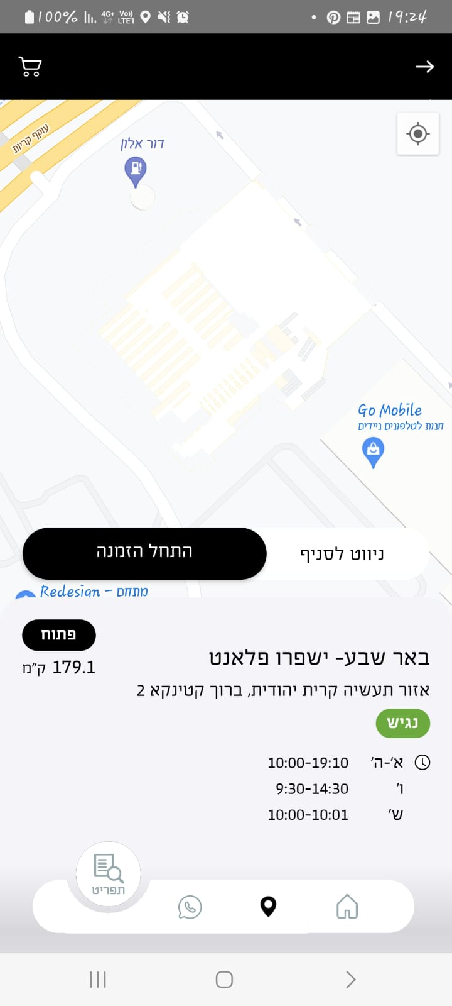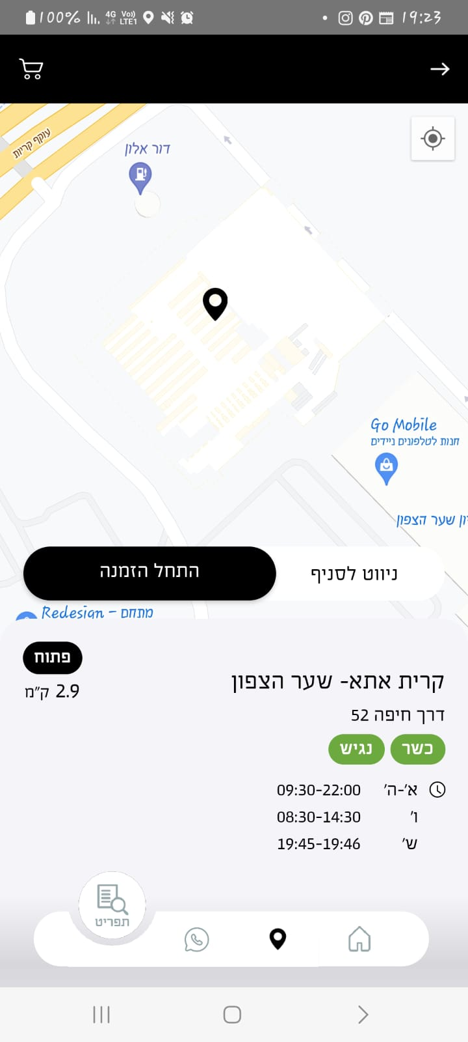



**Title: there is an error in the address of the branch**

**Description**: The address of the branch “טבריה ביג פאשן” is wrong

**Steps:**

1. Type “טבריה” in the search box

2. Click on “טבריה ביג פאשן” branch from the drop-down list

**Expected result**: The address of the branch “טבריה ביג פאשן” will be correct

**Actual result:** The address of the branch “טבריה ביג פאשן” is wrong

*****See attachment****

**Severity:low**

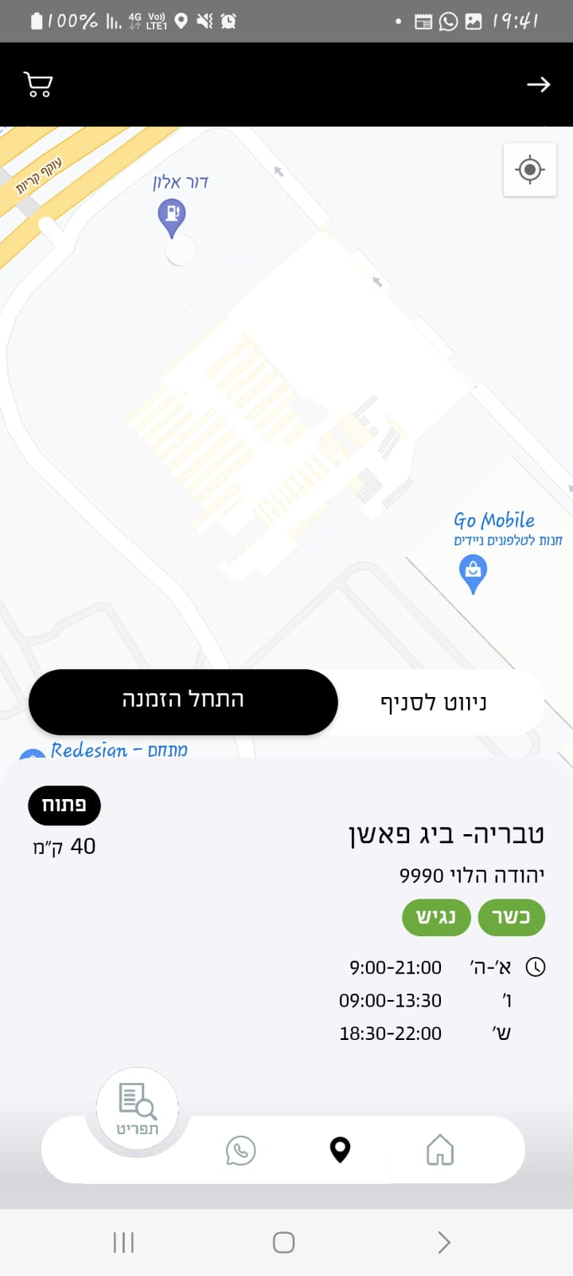

Test Description:   
I will test **search box** feature on “rebar” App

|  |  |
| --- | --- |
| **Test Purpose:** Making sure searching products by their categories and names is possible  **Test Run Instructions: <Describe any special instructions needed to execute this test>** | |
| **Test Run Information:**  **Tester Name:** **Sara Hayat**  **Date of Test:** **30/11/2023** | **Prerequisites for this test:** sim |
| **Software Versions:8.5.2**  Application: **rebar,Google Play**  Operating System: **Android 5.1**: |
| **Required Configuration: new user** |
| **NOTES and RESULTS:** | |

| **TEST SCRIPT STEPS/RESULTS** | | | | | |
| --- | --- | --- | --- | --- | --- |
| **STEP** | **TEST STEP/INPUT** | **EXPECTED RESULTS** | **ACTUAL RESULTS** | **Requirements Validated** | **PASS/FAIL** |
| **Sanity Functionality** | | | | | |
|  | Click on the search box | The keyboard will open | The keyboard opened |  | pass |
|  | Type “בננה” | A drop-down menu will open with all types of בננה”/products containing בננה” | A drop-down menu opened with all types of בננה”/products containing בננה” |  | pass |
|  | Type "banana" in the search box | A drop-down menu will open with all types of banana/products containing banana | A drop-down menu opened with all types of banana/products containing banana |  | pass |
|  | Type "שוקולד" in the search box | A drop-down menu will open with all types of "שוקולד"/products containing "שוקולד" | A drop-down menu opened with all types of שוקולד" /products containing שוקולד" |  | pass |
|  | Type "chocolate" in the search box | A drop-down menu will open with all types of "chocolate"/products containing "chocolate" | A drop-down menu opened with all types of "chocolate" /products containing "chocolate" |  | pass |
|  | Type "c" in the search box | A drop-down menu will open with all the products that have the letter "c" in their name | A drop-down menu opened with all the products whose name has the letter "c" |  | pass |
|  | Type "ג" in the search box | A drop-down menu will open with all the products that have the letter "ג" in their name | A drop-down menu opened with all the products whose name has the letter "ג" |  | pass |
|  | Type "מתוק" in the search box | A drop-down menu will open that includes "מתוק" | A drop-down menu opened that includes "מתוק" |  | pass |
|  | Click on "מתוק" in the drop down menu | A menu will open that includes all the products that fit the typed category | A menu opened that includes all the products that fit the typed category |  | pass |
|  | Delete the category "מתוק" by pressing on x | The category will be deleted and The menu will include general products and not by category | The category will be deleted and The menu included general products and not by category |  | pass |
|  | Type "sweet" in the search box | No results will be displayed | No results were shown |  | pass |
|  | Type "חמצמץ" in the search box | A drop-down menu will open that includes "חמצמץ" | A drop-down menu opened that includes "חמצמץ" |  | pass |
|  | Click on "חמצמץ" in the drop down menu | A menu will open that includes all the products that fit the typed category | A menu opened that includes all the products that fit the typed category |  | pass |
|  | Type "קר" in the search box | A drop-down menu will open that includes "קר" | A drop-down menu opened that includes "קר" |  | pass |
|  | Click on "קר" in the drop down menu | A menu will open that includes all the products that fit the categories "קר" and "חמצמץ" | A menu opened that includes all the products that fit the categories "קר" and "חמצמץ" |  | pass |
|  | Type "טבעוני" in the search box | A drop-down menu will open that includes "טבעוני" | A drop-down menu opened that includes "טבעוני" |  | pass |
|  | Click on "טבעוני" in the drop down menu | A menu will open that includes all the products that fit the categories "קר" and "חמצמץ" and "טבעוני" | A menu opened that includes all the products that fit the categories "קר" and "חמצמץ" and "טבעוני” |  | pass |
|  | Type "סורבה לימון" in the search box | A drop-down menu will open that includes "סורבה לימון" | A drop-down menu opened that includes "סורבה לימון" |  | pass |
|  | Click on "סורבה לימון" in the drop down menu | A menu will open that includes all the products that fit the categories "קר" and "חמצמץ" and "טבעוני" and "סורבה לימון" | A menu opened that includes all the products that fit the categories "קר" and "חמצמץ" and "טבעוני” and "סורבה לימון" |  | pass |
| 20 | type "מלון" in the search box | A drop-down menu will open that includes "מלון" | A drop-down menu opened that includes "מלון" |  | pass |
| 21 | Click on "מלון" in the drop down menu | A menu will open that includes all the products that fit the categories "קר" and "חמצמץ" and "טבעוני" and "סורבה לימון" and "מלון" | A menu opened that includes all the products that fit the categories "קר" and "חמצמץ" and "טבעוני” and "סורבה לימון" and "מלון" |  | pass |
| 1. 22 | Click on "נקה הכל" button | All categories will be delete and The menu will include general products and not by categories | All categories deleted and The menu included general products and not by categories |  | pass |
|  | Type "rejoy" in the search box | A drop-down menu will open that includes "rejoy" | A drop-down menu opened that includes "rejoy" |  | pass |
|  | Click on "rejoy" in the drop down menu | A menu will open that includes the product that fit the typed category | A menu opened that includes the product that fit the typed category |  | pass |
| 23 | Delete the category "rejoy" by pressing on x | The category will be deleted and The menu will include general products and not by category | The category will be deleted and The menu included general products and not by category |  | pass |
|  | Type "2023" in the search box | A drop-down menu will open that includes "2023" | A drop-down menu opened that includes "2023" |  | pass |
|  | Click on "hot 2023" in the drop down menu | A menu will open that includes all the products that fit the typed category | A menu opened that includes all the products that fit the typed category |  | pass |
| 25 | Delete the category "2023" by pressing on x | The category will be deleted and The menu will include general products and not by category | The category will be deleted and The menu included general products and not by category |  | pass |
| **Error handling** | | | | | |
|  | Type "?/.:](" in the search box | No results will be displayed | No results were shown |  | pass |
|  | Type "9264" in the search box | No results will be displayed | No results were shown |  | pass |
|  | Type "מתוק" in the search box | A drop-down menu will open that includes "מתוק” | A drop-down menu opened that includes "מתוק” |  | pass |
|  | click on "מתוק" in the drop down menu | A menu will open that includes all the products that fit the typed category | A menu opened that includes all the products that fit the typed category |  | pass |
|  | Type "חמוץ" in the search box | A drop-down menu will open that includes "חמוץ" | A drop-down menu opened that includes "חמוץ" |  | pass |
| 30 | Click on "חמוץ" in the drop down menu | An error message will appear "We didn't find what you were looking for. Want to search for something else?" | An error message appeared "We didn't find what you were looking for. Want to look for something else?" |  | pass |
| **GUI** | | | | | |
| 31 | Verify there are no spelling errors in the guideline inside the search box and drop-down menu | There will be no spelling errors inside the search box and drop-down menu | There are no spelling errors inside the search box and drop-down menu |  | pass |
| 32 | Verify what is shown in the menu according to the categories searched for | What is shown in the menu will match the categories we searched for | What was shown on the menu matched the categories we were looking for |  | pass |
| 33 | Type "ק" in the search box and Scroll down the drop-down menu to see the rest of the suggestions | The scrolling will let us reach to the end of the drop-down menu list and choose any of the options buy pressing one of the product lines | The scrolling let us reach to the end of the drop-down menu list and choose any of the options buy pressing one of the product lines |  | pass |
| 34 | Make sure you can see all the categories you have filtered in the search by swiping left and right | It will be possible to see all the categories clearly by swiping | It was not possible to swipe and to see all the categories clearly |  | Fail |

**Title: can't see all the categories you have chosen for filtering**

**Description**: It is not possible to see clearly all the categories we have chosen for filtering by swiping

**Steps:**

1. Type "חמצמץ" in the search box

2. Click on "חמצמץ" in the drop down menu

3. Type "קר" in the search box

4. Click on "קר" in the drop down menu

5. Type "טבעוני" in the search box

6. Click on "טבעוני" in the drop down menu

7. Type "סורבה לימון" in the search box

8. Click on "סורבה לימון" in the drop down menu

9. type "מלון" in the search box

10. Click on "מלון" in the drop down menu

**Expected result**: It will be possible to see clearly all the categories by swiping

**Actual result:** it was not possible to see clearly all the categories we have chosen for filtering by swiping

*****See attachment****

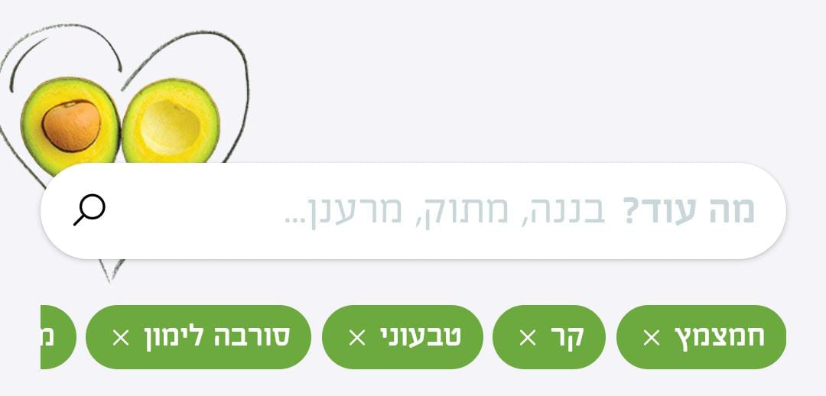

**Severity:low**

Test Description:   
check the feature **menu** on “rebar” App

|  |  |
| --- | --- |
| **Test Purpose:**  Make sure you can see all products by category, mark as "liked" and create a DIY  **Test Run Instructions: <Describe any special instructions needed to execute this test>** | |
| **Test Run Information:**  **Tester Name:** **Sara Hayat**  **Date of Test:** **03/12/2023** | **Prerequisites for this test:** sim |
| **Software Versions:8.5.2**  Application: **rebar,Google Play**  Operating System: **Android 5.1**: |
| **Required Configuration: new user** |
| **NOTES and RESULTS:** | |

| **TEST SCRIPT STEPS/RESULTS** | | | | | |
| --- | --- | --- | --- | --- | --- |
| **STEP** | **TEST STEP/INPUT** | **EXPECTED RESULTS** | **ACTUAL RESULTS** | **Requirements Validated** | **PASS/FAIL** |
| **Sanity Functionality** | | | | | |
|  | Navigate to the menu | The menu page will open | The menu page has opened |  | pass |
|  | Scroll down the menu to see all the products that can be ordered | All products that can be ordered will be displayed in the menu | All the products that can be ordered were shown in the menu |  | pass |
|  | Navigate to the “I'm hot” category and swipe right | All products of the I'm hot category will be displayed | All products of the I'm hot category have been shown |  | pass |
|  | Press on “gold & hot” in the category “I’m hot” | A page will open with details on: nutritional values, what the drink is made of, choosing: size, sweetness level and quantity and a button: to pay or to continue buying | A page open with details on: nutritional values, what the drink is made of, choosing: size, sweetness level and quantity and a button: to pay or to continue buying |  | pass |
| **Functionality negative** | | | | | |
|  | Click on button “to pay” without choosing size and sweetness level | The button will not clickable | The button could not clickable |  | pass |
|  | Click a button “to continue buying” without choosing a size | The button will not clickable | The button could not clickable |  | pass |
|  | In the quantity field press (-) once | The quantity will remain 1 | The quantity remained 1 |  | pass |
|  | In the “Sweetness Level” field, click "Much" | will be able to choose | It was possible to choose |  | pass |
|  | choose “cup” in the field ”What size do you like?” | will be able to choose | It was possible to choose |  | pass |
| **Functionality** | | | | | |
|  | In the quantity field press (+) once | The number will change to 2 | The number changed to 2 |  | pass |
|  | Click the button "Continue to buy" | The product will be added to the shopping cart and will return to the menu | The product has been added to the shopping cart and Returned to the menu |  | pass |
|  | Navigate to the “mix & creamy” category and swipe right | All products of the mix & creamy category will be displayed | All products of the I mix & creamy category have been shown |  | pass |
|  | Press on “creamy peanut butter” in the category “mix & creamy” | A page will open with details on: nutritional values, what the drink is made of and a choice of: measure, on what basis, add/remove to change?, would you like to upgrade?, amount and a button to: pay or continue buying | A page opened with details on: nutritional values, what the drink is made of and a choice of: measure, on what basis, add/remove to change?, would you like to upgrade?, amount and a button to: pay or continue buying |  | pass |
|  | Click a button “to pay” without choosing “size” and “sweetness level” | The button will not clickable | The button could not clickable |  | pass |
|  | Click a button “to continue buying” without choosing a size | The button will not clickable | The button could not clickable |  | pass |
|  | Click on “S 20 ₪” in the field ”What size do you like?” | will be able to choose | It was possible to choose |  | pass |
|  | Click on “M 26 ₪” in the field ”What size do you like?” | will be able to choose and the previous size is deleted | It was possible to choose and the previous size is deleted |  | pass |
|  | Click on “L 30₪” in the field ”What size do you like?” | will be able to choose and the previous size is deleted | It was possible to choose and the previous size is deleted |  | pass |
|  | Choose “goat yogurt 3₪” In the field "On what basis?" | will be able to choose | It was possible to choose |  | pass |
|  | In the “Sweetness Level” field click on "A little" | will be able to choose | It was possible to choose |  | pass |
|  | click on the search box In the field “add/remove/change? *Up to 3 components” | A page will open with a search box and a list of ingredients in creamy peanut butter: “חמאת בוטנים טבעית”, “בננה”, “תמר”, “חלב”, “קרח | A page opened with a search box and a list of ingredients in creamy peanut butter: “חמאת בוטנים טבעית”, “בננה”, “תמר”, “חלב”, “קרח |  | pass |
|  | Type "פקאן מקורמל" in the search box and click "פקאן מקורמל" in the drop-down list | A quantity selection of "פקאן מקורמל" will appear in the field add/remove/change? | A quantity selection of "פקאן מקורמל" appeared in the field add/remove/change? |  | pass |
|  | click on the search box and click on “בננה” in the list of ingredients in creamy peanut butter | A quantity selection of “בננה” will appear in the field add/remove/change? | A quantity selection of “בננה” appeared in the field add/remove/change? |  | pass |
|  | In the “Sweetness Level” field of “בננה”, click on "A little" | will be able to choose | It was possible to choose |  | pass |
|  | click on the search box and click on “תמר” in the list of ingredients in creamy peanut butter | A quantity selection of “תמר” will appear in the field add/remove/change? | A quantity selection of “תמר” appeared in the field add/remove/change? |  | pass |
|  | In the “Sweetness Level” field of “תמר”, click on "without" | will be able to choose | It was possible to choose |  | pass |
| **Error handling** | | | | | |
|  | Type again "פקאן מקורמל" in the search box | There will be no results in the dropdown list | There were no results in the dropdown list |  | pass |
|  | Add another product: “אגס” | A pop-up error message will appear "Maximum 3...less is more" | A pop-up error message appeared "Allow a maximum of 3...less is more" |  | pass |
| **Functionality** | | | | | |
|  | Click on x In the “Sweetness Level” field of “תמר” | The product will be removed and A pop-up message will appear "We have received the change you requested" with a cancel button | The product was removed and a pop-up message appeared "We received the change you requested" with a cancel button |  | pass |
| 30 | Click the cancel button in the message that appears | The removed product will be returned | The removed product has not returned |  | Fail |
| 31 | In the field "Would you like to upgrade?"  Press the (+) button 3 times of “חלבון סויה בטעם וניל 6₪” | The number 3 will appear in the square | The number 3 appeared in the square |  | pass |
| 32 | Press the (-) button once of “חלבון סויה בטעם וניל 6₪” | The number in the square will change to 2 | The number in the square changed to 2 |  | pass |
| 33 | Click on the square with the number 2 in it | The number will be deleted | The number has been deleted |  | pass |
| 34 | Press the (-) button 1 times in “חלבון סויה בטעם וניל 6₪” | Not clickable | Not clickable |  | pass |
| 35 | Click the button "Continue to buy" | The product will be added to the shopping cart and will return to the menu | The product has been added to the shopping cart and Returned to the menu |  | pass |
| 36 | Press on “כוס רב פעמית” in the category “rebar merch” | A page will open with details on: nutritional values, product description and selection of quantity and a button to: pay or continue buying | A page opened with details on: nutritional values, product description and selection of quantity and a button to: pay or continue buying |  | pass |
| 37 | Click on the "1 pc" button | will be able to choose | It was possible to choose |  | pass |
| 38 | Click the button "Continue to buy" | The product will be added to the shopping cart and will return to the menu | The product has been added to the shopping cart and Returned to the menu |  | pass |
| 39 | Press on “אסאי 100 גרם” in the category “frozen fruits” | A page will open with details on: nutritional values, product description and selection of quantity and a button to: pay or continue buying | A page opened with details on: nutritional values, product description and selection of quantity and a button to: pay or continue buying |  | pass |
| 40 | Click on the "1 pc" button | will be able to choose | It was possible to choose |  | pass |
| 41 | Click the button "Continue to buy" | The product will be added to the shopping cart and will return to the menu | The product has been added to the shopping cart and Returned to the menu |  | pass |
| 43 | Press on “regurt בכוס” in the category “DIY” | A page will open with details on: nutritional values, product description and selection of size, quantity and would you like to upgrade? And a button: pay or continue buying | A page opened with details on: nutritional values, product description and selection of size, quantity and would you like to upgrade? And a button: pay or continue buying |  | pass |
| 44 | Click a button “to pay” without choosing size and sweetness level | The button will not clickable | The button could not clickable |  | pass |
| 45 | Click a button “to continue buying” without choosing a size | The button will not clickable | The button could not clickable |  | pass |
| 46 | Click on "Nutrition Values" | A page will open with details on the nutritional values of the product | A page has opened with details on the nutritional values of the product |  | pass |
| 47 | Verify It is possible to close the page “nutritional values” by pressing x | will pass successfully | succeeded |  | pass |
| 48 | Click on “S 19₪” in the field ”What size do you like?” | will be able to choose | It was possible to choose |  | pass |
| 49 | Click on “M 22 ₪” in the field ”What size do you like?” | will be able to choose and the previous size is deleted | It was possible to choose and the previous size is deleted |  | pass |
| 50 | Click on “L 25₪” in the field ”What size do you like?” | will be able to choose and the previous size is deleted | It was possible to choose and the previous size is deleted |  | pass |
| 51 | In the field "Would you like to upgrade?"  Press the (+) button once in 3₪ “יוגורט עיזים” | The number 1 will appear in the square | The number 1 appeared in the square |  | pass |
| 52 | Click the button "Continue to buy" | The product will be added to the shopping cart and will return to the menu | The product has been added to the shopping cart and Returned to the menu |  | pass |
| 53 | Press on “DIY” in the category “DIY” | A page will open with details on: nutritional values, product description and selection: measure, on what basis, what to add/remove to change?, would you like to upgrade?, quantity and a button to: pay or continue buying | A page opened with details on: nutritional values, product description and selection: measure, on what basis, what to add/remove to change?, would you like to upgrade?, quantity and a button to: pay or continue buying |  | pass |
| 54 | Verify that no default is selected for any field | There will be no default in any field | There was no default in any field |  | pass |
| 55 | Click on “M 26 ₪” in the field ”What size do you like?” | will be able to choose | It was possible to choose |  | pass |
| 56 | Choose “משקה סויה וניל” In the field "On what basis?" | will be able to choose | It was possible to choose |  | pass |
| 57 | click on the search box In the field “add/remove/change? *Up to 5 components” | A page will open with a search box | A page opened with a search box |  | pass |
| 58 | Type "חמאת בוטנים טבעית" in the search box and click “חמאת בוטנים טבעית" in the drop-down list | A quantity selection of חמאת בוטנים טבעית" will appear in the field “add/remove/change?” | A quantity selection of חמאת בוטנים טבעית" appeared in the field add/remove/change? |  | pass |
| 59 | Type "פקאן מקורמל" in the search box and click on "פקאן מקורמל" in the drop-down list | A quantity selection of "פקאן מקורמל" will appear in the field “add/remove/change?” | A quantity selection of "פקאן מקורמל" appeared in the field add/remove/change? |  | pass |
| 60 | Type "קקאו אורגני" in the search box and click on "קקאו אורגני" in the drop-down list | A quantity selection of "קקאו אורגני" will appear in the field “add/remove/change?” | A quantity selection of ""קקאו אורגני" appeared in the field add/remove/change? |  | pass |
| 61 | Type "בננה" in the search box and click on "בננה" in the drop-down list | A quantity selection of "בננה" will appear in the field “add/remove/change?” | A quantity selection of "בננה" appeared in the field add/remove/change? |  | pass |
| 62 | Type "קרח" in the search box and click on"קרח" in the drop-down list | A quantity selection of "קרח" will appear in the field “add/remove/change?” | A quantity selection of "קרח"appeared in the field add/remove/change? |  | pass |
| 63 | Add another product: “אגס” | A pop-up error message will appear "Maximum 5...less is more" | A pop-up error message appeared "Allow a maximum of 5..less is more" |  | pass |
| 64 | In the field "Would you like to upgrade?"  Press the (+) button once in “6₪ חלבון סויה בטעם וניל” | The number 1 will appear in the square | The number 1 appeared in the square |  | pass |
| 65 | In the quantity field press (+) once | The number will change to 2 | The number changed to 2 |  | pass |
| 66 | Click the button "Continue to buy" | The product will be added to the shopping cart and will return to the menu | The product has been added to the shopping cart and Returned to the menu |  | pass |
| 67 | Click on the heart button on the “gold & hot” product in the “I'm hot “ category | The product will be marked as I like it with a red heart | The product was marked as my favorite with a red heart |  | pass |
| 68 | Click on the heart button on the “choc & hot” product in the “I'm hot “ category | The product will be marked as my favorite with a red heart | The product was marked as my favorite with a red heart |  | pass |
| 69 | Swipe right on a category “I'm hot” | In the rest of the products  a red heart will not appear | in pro & hot and match & hot and oat & hot A red heart appeared and disappeared |  | fail |
| 70 | Swipe right on a category “rebar & classics” without marking any product as favorite | No product will appear with a red heart | in refemme and reshape A red heart appeared and disappeared |  | fail |
| 71 | Click on the heart button on the “relax” product in the “rebar & classics” category | The product will be marked as my favorite with a red heart | The product was marked as my favorite with a red heart |  | pass |
| 72 | Swipe right on a category “rebar & classics” | In the rest of the products  a red heart will not appear | in reshape A red heart appeared and disappeared |  | fail |
| 73 | Click on the red heart button on the “relax “product in the “rebar & classics” category | The red heart will be canceled | The red heart has been canceled |  | pass |
| **Usability** | | | | | |
| 74 | verify In the Sweetness Level field "Normal" is marked by default | "Normal" will be checked by default | "Normal" was checked by default |  | pass |
| 75 | Verify in the quantity field that number 1 is selected by default | Number 1 is selected by default | Number 1 is selected by default |  | pass |
| **Gui** | | | | | |
| 76 | Verify that the displayed image matches the product | will pass successfully | succeeded |  | pass |
| 77 | Press on “creamy peanut butter” and Click on “M 26₪” in the field of size | The size we chose will be marked in green | The size we chose was marked in green |  | pass |
| 78 | in the field "Would you like to upgrade?"  Press the (+) button 2 times in חלבון סויה בטעם וניל” 6₪” | The square next to the field is marked in green with the number 2 in it | The square next to the field is marked in green and the number 2 has appeared in it |  | pass |
| 79 | check the correctness of the proofreading that there are no spelling errors | No spelling errors | No spelling errors |  | pass |
| 80 | Click on the tooltip in the product “relax” in the “rebar & classics” category | An information window will open with the components of the product | An information window was opened with the components of the product |  | pass |

**Title: Deleting a component and canceling deletion - doesn't retrieve it.**

**Description**: When you delete a component, a message appears with a button to cancel, but when you click on it, it does not return the removed component

**Steps:**

1.Press on creamy peanut butter in the category mix & creamy

2. click on the search box

3. click on “תמר” in the list of ingredients in creamy peanut butter

4. choose "בלי" In the Sweetness Level of “תמר”

5. Click on x In the Sweetness Level of “תמר”

6. Click on cancel button in the message that appears

**Expected result**: After clicking the cancel button the removed component will return

**Actual result:** The removed component did not return after pressing the cancel button

*****See attachment****

**Severity:low**

3) 2) 1)

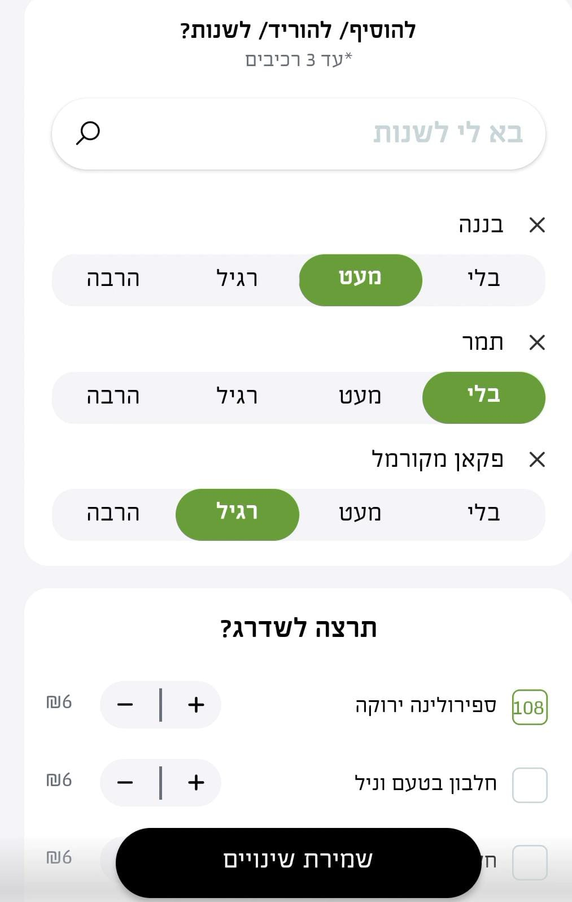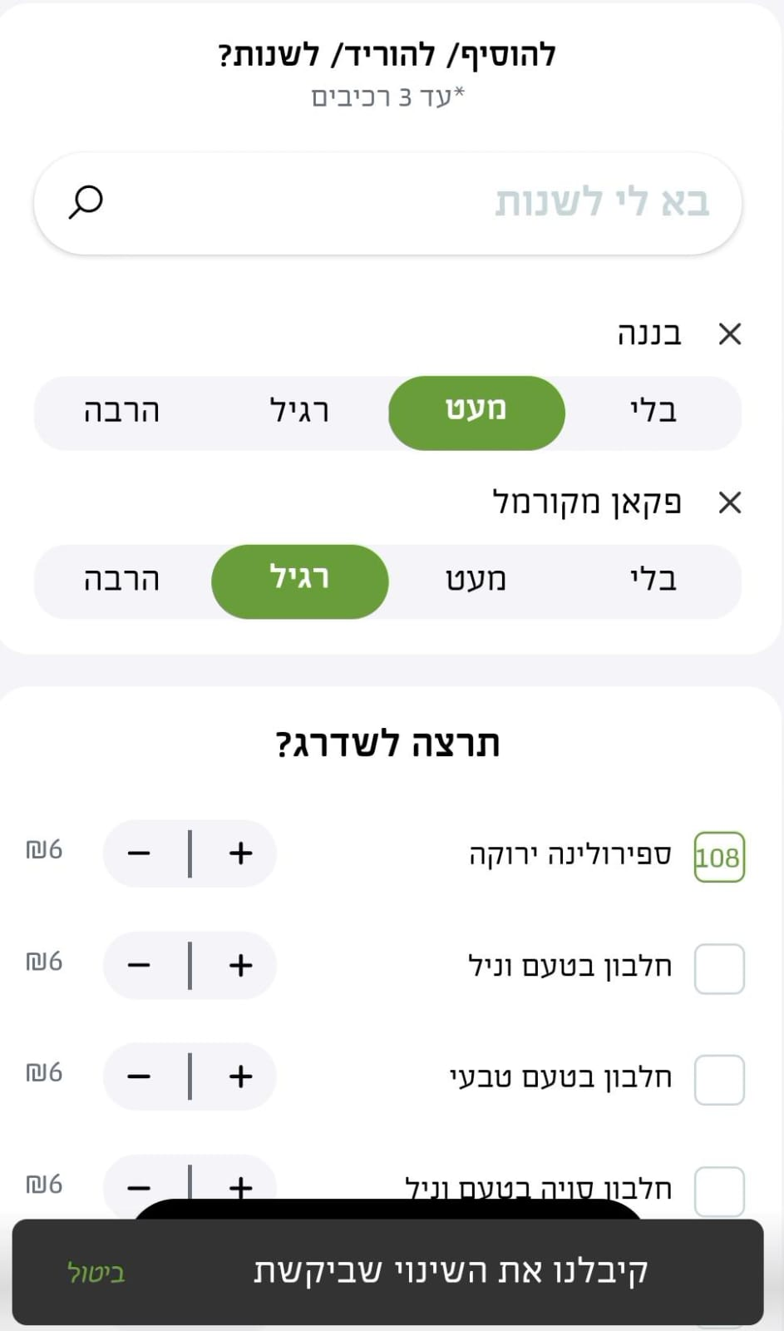

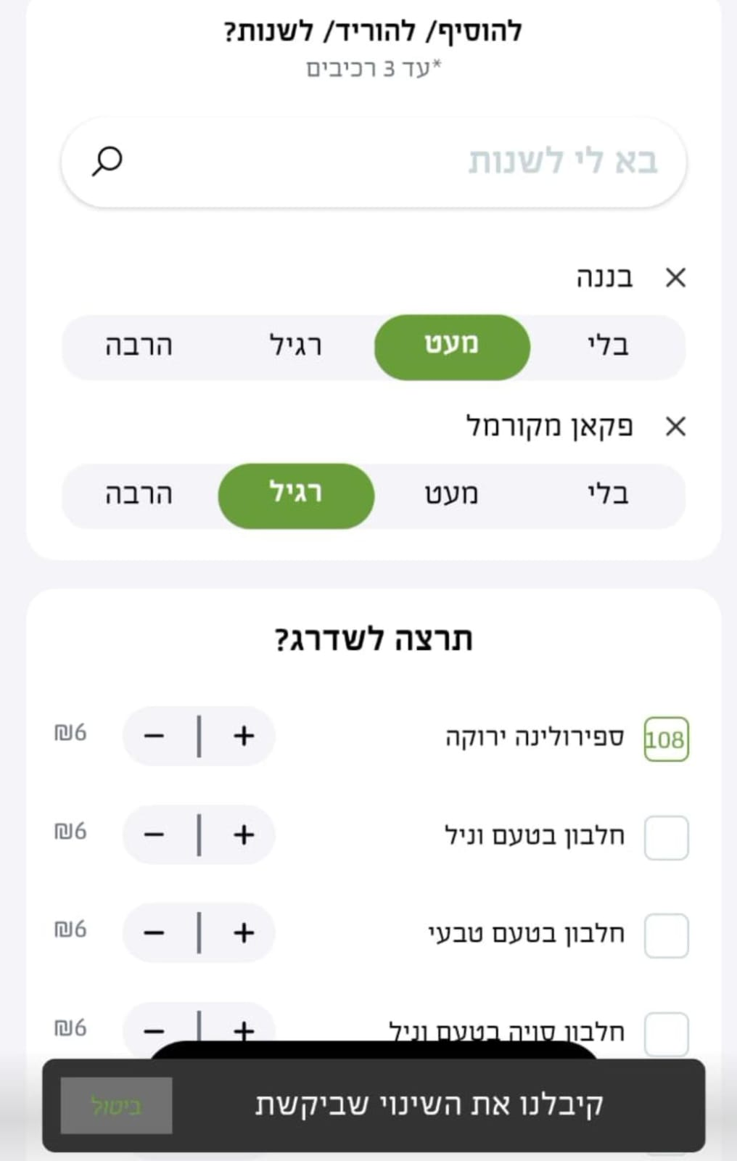

**Title: There is an error in marking products as "favorite"**

**Description**: When you mark a product as a favorite by red heart and swipe to see all the products in the category, additional products have been marked as favorites

**Steps:**

1. Click on the heart button on the gold & hot product in the I'm hot category

2. Click on the heart button on the choc & hot product in the I'm hot category

3. Swipe right on a category I'm hot

4. Swipe right on a category rebar & classics without marking any product as favorite

5. Click on the heart button on the relax product in the rebar & classics category

6.Swipe right on a category rebar & classics

**Expected result**: Only products I have marked as favorites will appear with a red heart

**Actual result:** additional products have been marked as favorites

**Severity:low**